

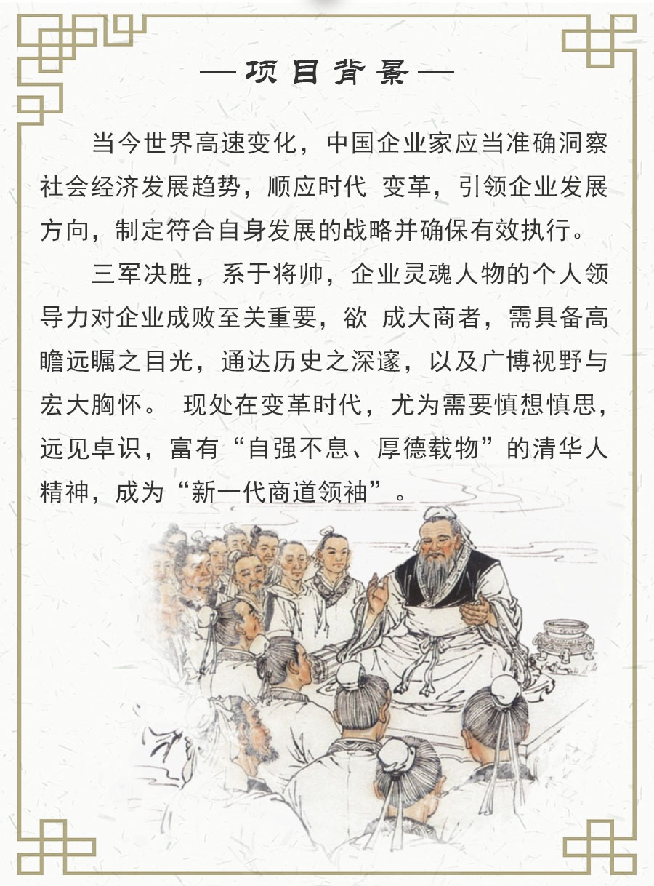

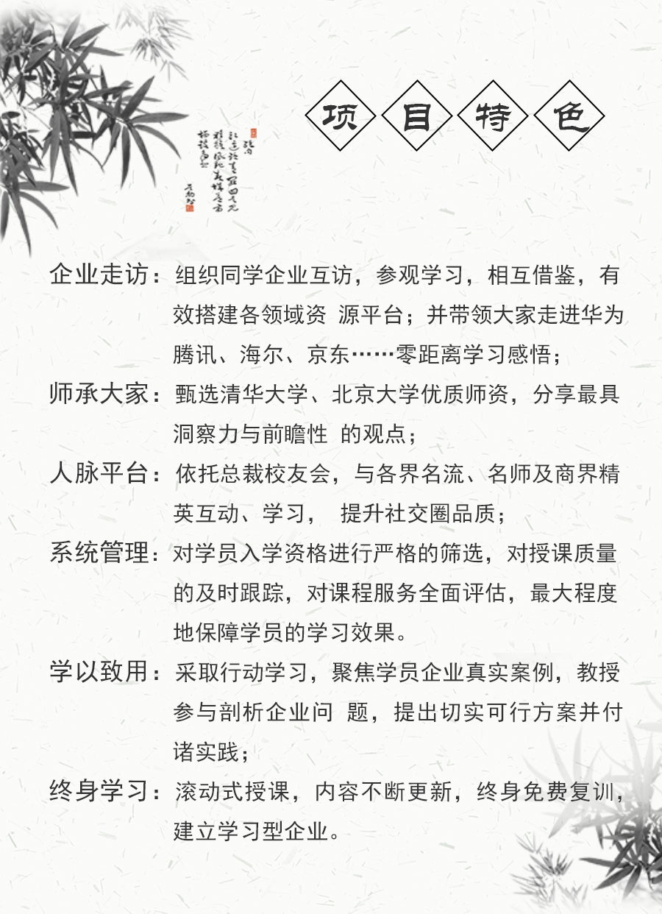

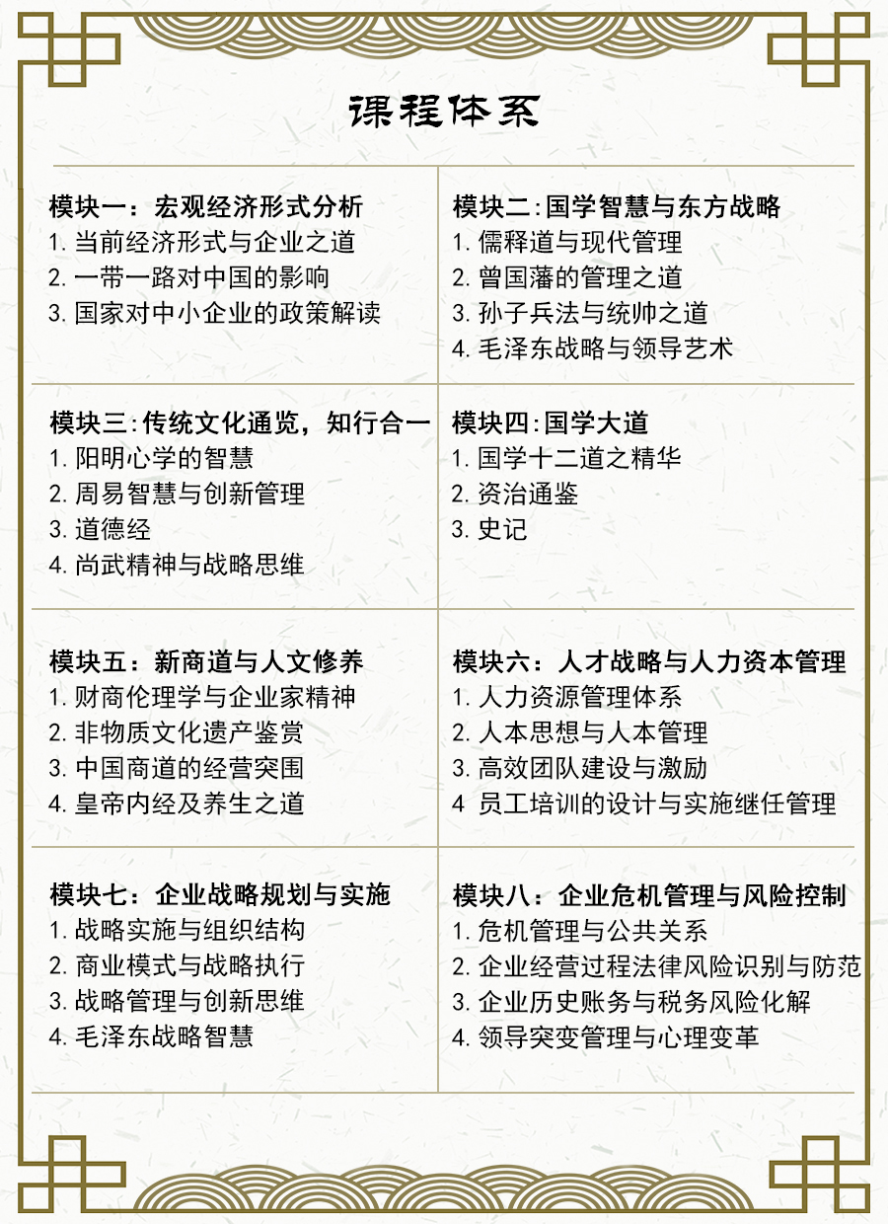

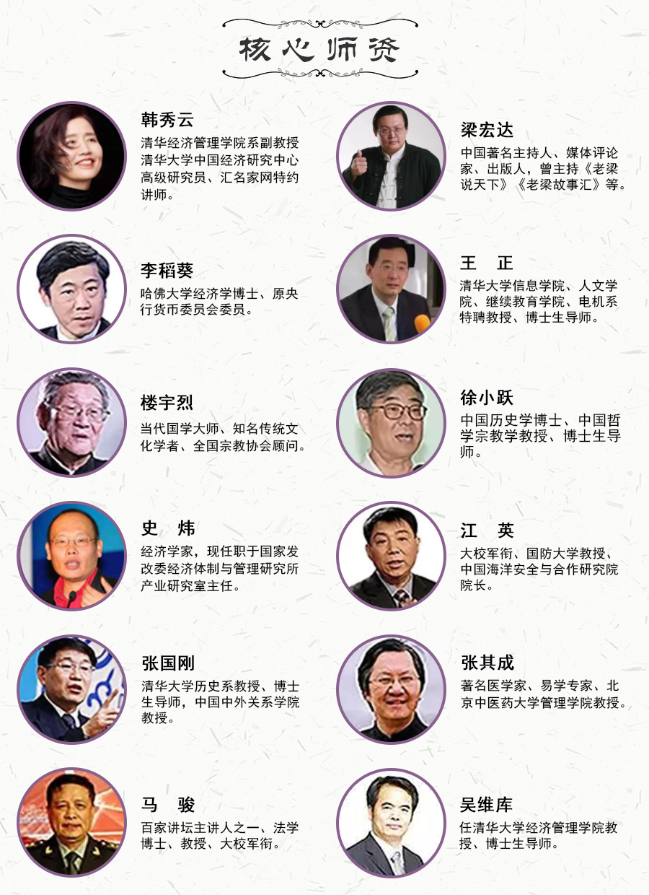

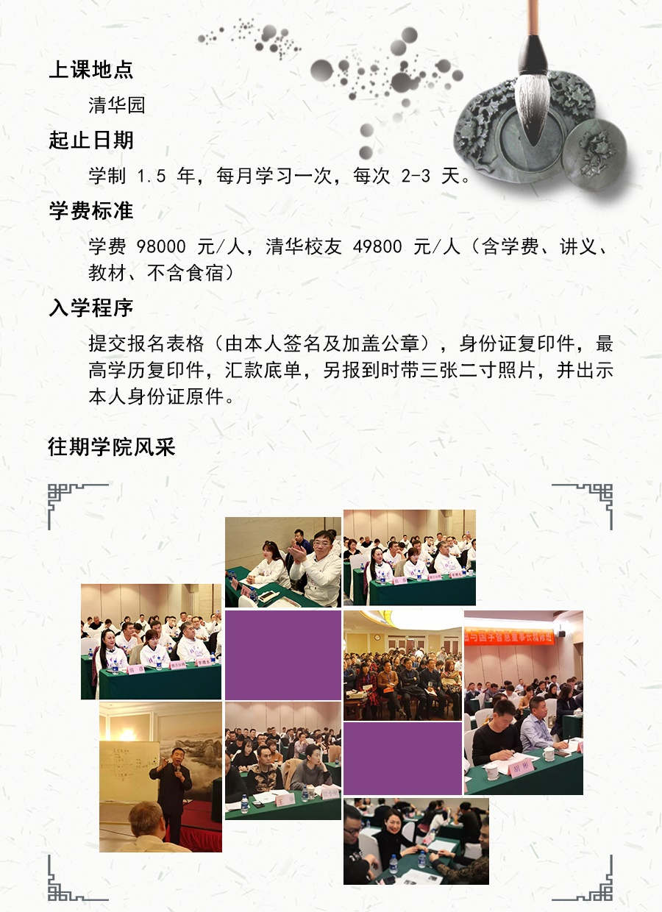

**新商道领袖与国学智慧董事长精修班**

报 名 表

|  |  |  |  |  |  |  |  |  |  |  |  |  |  |  |  |  |  |  |  |  |  |  |  |  |  |  |
| --- | --- | --- | --- | --- | --- | --- | --- | --- | --- | --- | --- | --- | --- | --- | --- | --- | --- | --- | --- | --- | --- | --- | --- | --- | --- | --- |
| **姓 名** |  | | | | | | | **性别** | | |  | | | **年龄** | | |  | | | | | **贴照片** | | | | |
| **工作单位** |  | | | | | | | | | | | | | **职位** | | |  | | | | |
| **单位地址** |  | | | | | | | | | | | | | **邮编** | | |  | | | | |
| **固定电话** |  | | | | | | | | | **传真** | | | |  | | | | | | | |
| **手 机** |  | | | | | | | | | **E-mail** | | | |  | | | | | | | | | | | | |
| **身份证号码** |  |  |  |  | |  |  | |  | | |  |  |  | |  | |  |  | |  | |  |  |  |  |
| **教育背景** | **毕业院校** | | | |  | | | | | | | | | | **学历与学位** | | | | |  | | | | | | |
| **毕业时间** | | | |  | | | | | | | | | | **专业** | | | | |  | | | | | | |
| **工作简历** |  | | | | | | | | | | | | | | | | | | | | | | | | | |
| **是否预定房间** | **□需要　 □不需要** | | | | | | | | | | | | | | | | | | | | | | | | | |
| **您的建议与要求：**  **申请人：**  **年 月 日** | | | | | | | | | | | | | | | | | | | | | | | | | | |
| **汇款方式**  **□ 汇款 □ 支票 □ 现金 （请在框内用＂√＂标注）** | | | | | | | | | | | | | | | | | | | | | | | | | | |
| 注： 请在汇款单“汇款用途”栏注明“XXX 学费”字样请将汇款票据分别传真至： | | | | | | | | | | | | | | | | | | | | | | | | | | |

[报名表填好后EMAIl至271916126@qq.com](mailto:报名表填好后EMAIl至271916126@qq.com) 电话：13439064501 陈老师

本表复印或传真均有效，请务必详实完整填写。